**Deify Helman Key Exchange Algorithm**

Basic Overview : Diffie Hellman Key Exchange Algorithm is used for key exchange. The basic idea behind this algorithm is that Alice and Bob exchange their public keys over an insecure channel. The secret key or the private key remains private to both the individual and the message can be encrypted only by the secret key. Even if somebody in the middle intercepts the public key they can’t decrypt the message key because they don’t know the secret keys.

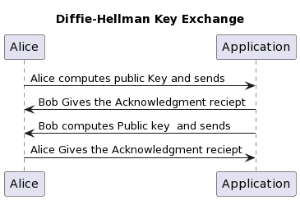Sequence Diagram :

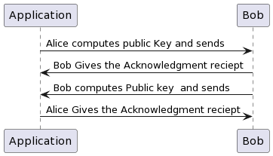

Class Diagram:

To establish Diffie Hellman Key Exchange Algorithm it is very essential to keep the private key secret from everyone

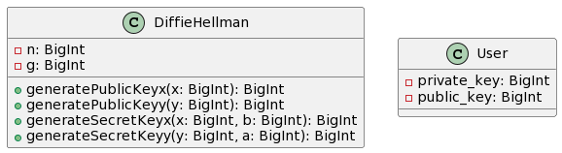

Output Screenshot:

